ABOUT THE UNITED HORNED HAIR SHEEP ASSOCIATION, Inc.
The United Horned Hair Sheep Association, Inc., with 9 divisions representing the sheep breeds of: Painted Desert, Texas Dall, Black Hawaiian, Corsican, Desert Sand, Multi-horned Hair, New Mexico Dahl, American Heavy Horned and Mouflon began Registrations in the Late Fall of 2009.
Founded in April 2009, the organization was officially recognized as an Incorporated Non-Profit Corporation on July 6, 2009.
A group of sheep breeders, from across the nation, created a national non-profit organization which is dedicated to serving the members and the public.
When in conception and development, there were no other registries for Texas Dall, Black Hawaiian, Corsican, Desert Sand, nor Mouflon Sheep. As for the Painted Desert sheep breed, there was a need to move away from a sole-proprietorship registry to a member
owned and member operated non-profit organization to help benefit and promote this breed.
Including all the divisions of these separate but related sheep and one of their parent breeds, the Mouflon, seemed to be the best way to produce an organization that would be positioned to promote and educate other sheep breeders and the general public about the breeds represented.
On January 26, 2013, at the Member Meeting, the official recognition and addition of two more breeds was enacted by paper and electronic ballots: The Multi-horned Hair Sheep Breed and the New Mexico Dahl Sheep Breed. At the April 27, 2017 Member Meeting, another breed division for American Heavy Horned Sheep was approved.
Our Purpose from our ARTICLES of INCORPORATION
1. To engage in the promotion, conservation, education and furtherance of public awareness of each of the breeds represented
2. To assist members in developing new markets and expanding current markets
3. To keep a breed standard which will serve to identify and register individual animals which qualify as one of the breeds represented
4. To promote interest in the breeds represented and whenever possible to attract new breeders for promotion, preservation, & wellbeing of the breeds
5. To register and keep pedigrees and records of all animals that qualify as one of the breeds represented The Registry portions of each division are dedicated to serving as a holding place for Official Records of Pedigrees based on information that members submit
to the registry
6. To promote more education, research or studies on the advantages of hair or shedding sheep and diseases affecting sheep in general
Below are some of the activities which the United Horned Hair Sheep Association, Inc., hopes to participate in and offer:
- Offer electronic registration submission
- Assist with staffing or financing booths at Fairs/Shows
- Finance youth and adult scholarships
- Host educational gatherings, in person or internet
- Regularly produce a newsletter(s)
- Promote, as able, shows which allow the breeds represented by UHHSA, Inc., to be shown
- Encourage members to participate in studies and research promoted by universities in the USA
- Provide written articles for periodicals, books, or websites related to sheep and farming
We hope you will come and join us in our efforts for these wonderful sheep!
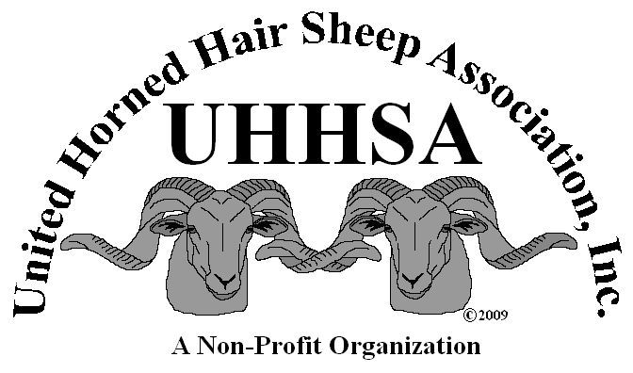

United Horned Hair Sheep Association, Inc

A Non-Profit Organization
Representing:
Painted Desert Sheep,
Texas Dall Sheep,
Black Hawaiian Sheep,
Corsican Sheep,
Desert Sand Sheep,
Multi-horned Hair Sheep,
New Mexico Dahl Sheep,
Mouflon Sheep, &
American Heavy Horned Sheep

www.unitedhornedhairsheepassociation.org
uhhsa@yahoo.com

937-430-1768 (UHHSA Office, Sara Qualls)
270-525-9977 (Valerie Smith, President)
281-468-7744 (Brenda Savage, OR Inspector)
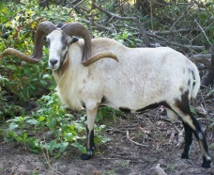
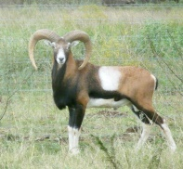
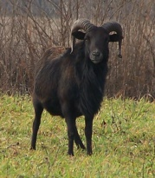
History: Painted Desert, Texas Dall, Black Hawaiian, Desert Sand, and Corsican sheep are actually the result of initial crosses decades ago between the shedding, European Mouflon Sheep (Ovis musimon, native to Corsica and Sardinia) with a wide range of more well known “wool” breeds of sheep including: Rambouillet, Churro, Merino, and Jacob. At times, some of the initial crosses also included a hair or shedding sheep called the Barbados Blackbelly (Ovis aries) which was imported from the Caribbean Island of Barbados, West Indies with bloodlines originally coming from Africa.

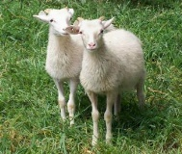
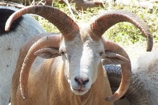
New Mexico Dahl Sheep is a breed being resurrected as a heritage link between the first importation of sheep into the Southwestern US, sheep found on old Land Grants and written about in Spanish Archives and family journals.
Multi-horned Hair Sheep breed – a developing breed offering sheep that display and/or produce sheep with more than 2 horns while maintaining a shedding ability.
American Heavy Horned Sheep division is for a developing breed utilizing Bighorn, Alaskan Dall, or Stumberg sheep influences to produce larger bodies and basal circumferences.

Horns: Horns are required on all rams. Ram lambs usually will display 1 to 3+ inch of horn growth by age 3 months. Some rams and ewes of certain breeds may display more than 2 horns. NM Dahl Ewes must display 2 horns.
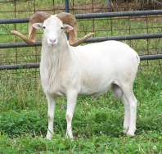
Coat – NO SHEARING: These sheep are considered a hair or shedding sheep. The sheep shed a thicker winter more wooly undercoat in Spring/Summer, leaving a slick hair type coat.

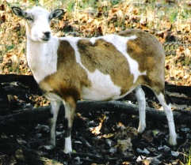
Coat – COLORS: Coat colors of the sheep represented by UHHSA, Inc., range from the spotted Painted Desert, all white Texas Dall, solid black Black Hawaiians, brown/black Corsicans, brown/black/white NM Dahl Onate, to champagne colored Desert Sands, and of course with the Mouflon being one of the most colorful “wild” sheep, there is sure an eye catching color with the UHHSA breeds for everyone to enjoy!

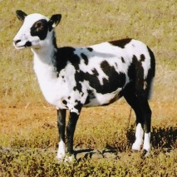
Size: Sizes of the breeds range from 60 lbs. - 120 lbs. for a mature ewe. Rams may weigh 75 – 200 + lbs. The sheep range from 19 inches at the withers for ewes to 35+ inches at the withers for rams.

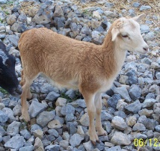
Nature and Care: These sheep flock well and can be tamed though taming of intact rams is cautioned.

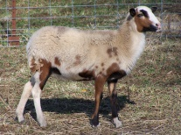
4ft fence is usually adequate, though some of the sheep may be able to clear the fence if pushed. An area to catch or work the sheep is really helpful.
These sheep are generally more able to withstand internal parasites than most wool breeds and with the shedding ability external parasites can easily be kept at minimum.
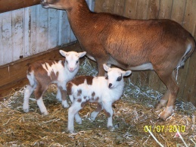
Trimming hooves may be necessary due to farm specific soil qualities.

Lambing: While Mouflon ewes will tend to give only single lambs, some of the breeds may present multiple births including Quadruplets. These sheep are good mothers though animal husbandry practices should always be followed.

Markets: These sheep are multi-market oriented which is extremely beneficial to the economy-wise shepherds.

The meat is perfect for today’s families which may not consume a large amount of meat at once or have a large freezer for storage. The meat is very lean and tasty with none of the strong “mutton” flavor found in wool sheep.

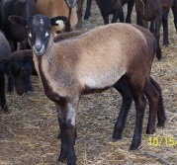
Horns and pelts can be used to make buttons, cane handles, crafts, garments, and wall hangings. More of the sheep sent for meat is used – less waste! Some people will brush their sheep or pick up the patches of shed wool and collect for crafts.

These sheep are excellent at keeping fence lines, weed lots and large lawns looking nice. Plus, they look good doing it and add natural fertilizer as they go!

Quality breeding stock is always in demand from dependable, ethical, and honest farms and ranches.

Live sheep shows are a relatively new venue for UHHSA, Inc, represented breeds. Painted Desert and Texas Dall Sheep have been shown! Be part of the future!

